Mr. Wangda Gyeltshen, EID No. 8205052, LHS, RNR-EC, Namgaycholing, Tashicholing Dungkhag under Samtse Dzongkhag superannuate from the civil service on 1st October, 2018 after 36 of dedicated service to the Tsa-Wa-Sum.
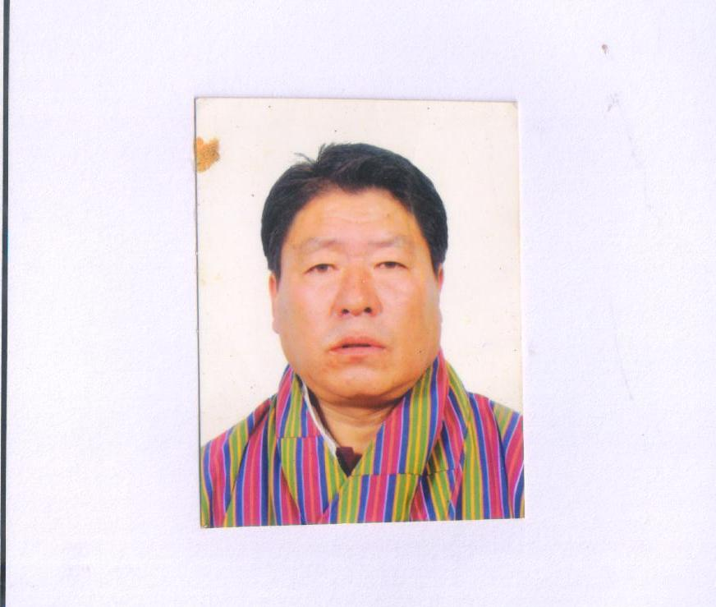
The Samtse Dzongkhag Administration, on behalf of the Royal Government of Bhutan, takes this opportunity to thank him for his commitment and contribution to the Royal Government of Bhutan.
We heartily congratulate him for his successful 36 years of dedicated service to the Tsa-Wa-Sum and wish him and his family a very happy and peaceful life ahead.

