Mr. Lham Penjor, EID No. 8403051, Principal II of Ugyentse Primary School under Samtse Dzongkhag superannuated from the civil service on 5th August, 2018 after 34 years 5 Months of dedicated service to the Tsa-Wa-Sum.
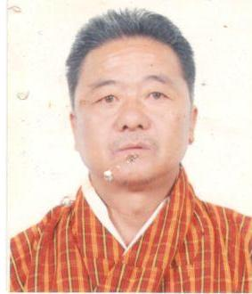
Mr. Lham Penjor started his career as a Teacher from Edi Primary School under Zhemgang Dzongkhag in the year 1984. He also served in various remote schools like Tang Primary School (Bumthang), Bardo Primary School (Zhemgang), Jamkhar Primary School (Tashiyangtse) and Phuensum Primary School (Samtse) before joining Ugyentse Primary School at various capacities.
The Samtse Dzongkhag Administration, on behalf of the Royal Government of Bhutan, takes this opportunity to thank him for his commitment and contribution to the Royal Government of Bhutan.
We heartily congratulate him for his successful 34 years and 5 Months of dedicated service to the Tsa-Wa-Sum and wish him and his family a very happy and peaceful life ahead.

Dzongkhag Administration
Samtse

